03.11.2023

No: SVGU/UO/Exam/2023/013

**Exam Form-Filling Circular for BBA-HHM**

The University Exam dates for Semester 1 have been announced. Students are requested to log in to the Student Portal with their **Student Login ID** and fill up the exam form and complete the payment of their exam fee online. You will be able to generate the Hall Ticket only after successful payment of your exam fee.

**The last date for filling the forms is 23.11.2023**. In case of any difficulty, you can get in touch with the Admin Office at the University.

Follow the below links:

Select and click Examination Form:

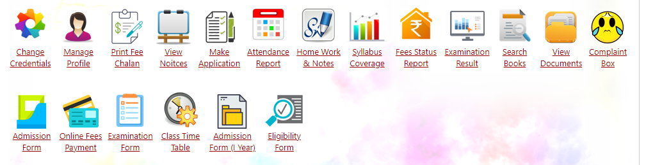

Click on Examination form:

Select in drop down in sequence:

Click on Generate form then the form will display. Click on declaration. Once it is done click on submit.

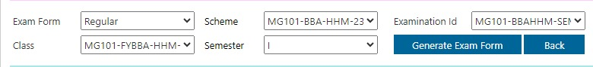

After submission the below screen will appear:

Click on Pay fee and pay the fee online. It is compulsory to pay online.

**Once you pay the fee then wait for payment success message in ERP.**

**Do not close the window.**



**Registrar**